|  |
| --- |
|  |

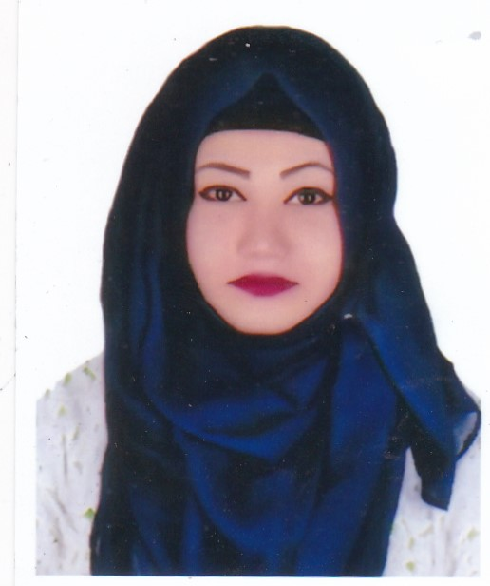

Ruhana Tasneem Jeba

58/36/5-A Flat-8B, North Mugda, Dhaka-1214 | Cell: 01688929392 | email: ruhanatasneem92@gmail.com

Objective

A full-time position in a reputed organization, preferably in Finance or any other department where I can explore my capabilities and gradually develop my knowledge, skill and abilities to perform duties and responsibilities.

Skills

❖ **Leadership:**Performed the duties of representative at the various events for multiple times, which  
requires maintaining active commutation with the higher and staffs.  
❖ **Language and communication:**Good written and oral communication skills in both English and Bangla. As a part of  
MBA program, gained experience in expressing business terms in an easy-to-understand  
written language.  
❖ **Personal Traits:**▪Hard-working attitude & ability to work under stressful condition.   
▪Fast-learning attitude, team player, self-motivated and ability to take responsibilities.   
▪Strong leadership and analytical skills.   
▪Excellent administrative, communicative, and interpersonal skill. 

**Computer and technological skills:**

❖ **Software Applications:** Excellent skills and operating capacity in MS Office, MS Excel,  
Power Point.  
❖ **Web Browsing:** Well capable of web browsing and data editing and processing in a  
formal way by soft copy and hard copy depends on right situation.

Professional Experience

* *Accountant* (October 1, 2018 – July 28, 2021)

**Rahman Group**

*Duties and responsibilities:*

* Updating financial statements.
* Maintaining accounts receivable and accounts payable.
* Paying monthly payroll.
* Preparing financial reports.

Academic Qualification

|  |  |  |  |  |
| --- | --- | --- | --- | --- |
| **Exam Title** | **Concentration/Major** | **Institute** | **Result** | **Pas.Year** |
| MBA | Management | National University, Khilgaon Model Collage,Dhaka | CGPA:3.03 out of 4 | 2017 |
| HONOUS | Management | National University, Khilgaon Model Collage,Dhaka | CGPA:2.72 out of 4 | 2016 |
| H.S.C | commerce | Mohanagar Ideal Collage | CGPA:3.70 out of 5 | 2012 |
| S.S.C | commerce | Haider Ali High School & Collage | CGPA:3.63 out of 5 | 2010 |

Personal Information

*Father’s Name*: Late Esmail Hossain

*Mother’s Name*: Sultana Afroz

Husband’s Name: S.M. Arefin Rumi

*Date of Birth*: 09 December 1995

*Gender*: Female

*Marital Status*: Married

*Nationality*: Bangladeshi by born

*National ID No.*: 3703277941

*Religion*: Islam

*Permanent Address*: 58/36/5-A Flat-8B North Mugdapara Modinabag Wasa Road Dhaka 1214

*Current Location*: Dhaka

Reference

*Name*: S.M. Arefin Rumi

*Designation*: IT Infrastructure Engineer

*Organization*: SynesisIT Ltd.

*Cell*: 01687345253

*Email*: smarefin7@gmail.com

*Name*: Dr.Md. Mustafizur Rahman

*Designation*: Associate Prof. & Head of Dept. Urology.

*Organization*: Mugda General Hospital, Dhaka

*Cell*: 01711965627

*Email*: maruf.hossain@outlook.com

|  |
| --- |
|  |

I do hereby declare that all the above information is true and correctly describes my qualifications and myself to the best of my knowledge.



Ruhana Tasneem Jeba